
Profield Chat v1
User Guide
Revision History
Version | Author | Date | Remarks
1.0 | Midhun KC | 26 Aug 2020 | Created

- Table of Contents
1 ADMIN MODULE 3
1.1 ADD CUSTOMER 3
1.2 EDIT CUSTOMER 4
1.3 CLEAR CHAT 4
2 WEB APPLICATION (CLIENT) 5
2.1 CUSTOMER SIGN UP 5
2.2 ONLINE/OFFLINE CONTACTS 8
2.3 CHAT SCREEN 9
2.4 DELETE MESSAGES 13
2.5 REPLY MESSAGE 13
2.6 ACCOUNT REACTIVATE 14
3 IOS APP (CLIENT)

ADMIN MODULE
The administrator can login to the system using the,
URL: https://hikari.in/profield-chat/admin/
User name :superadmin
Password : 123456
On successful login the Admin Main window will be displayed.
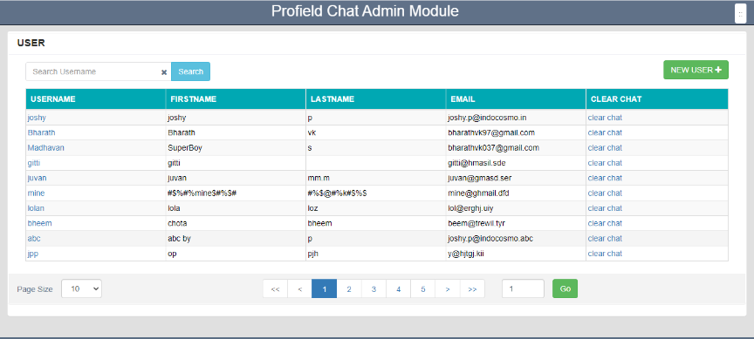
The admin module allow administrator to setup and maintain the Customer:

ADD CUSTOMER
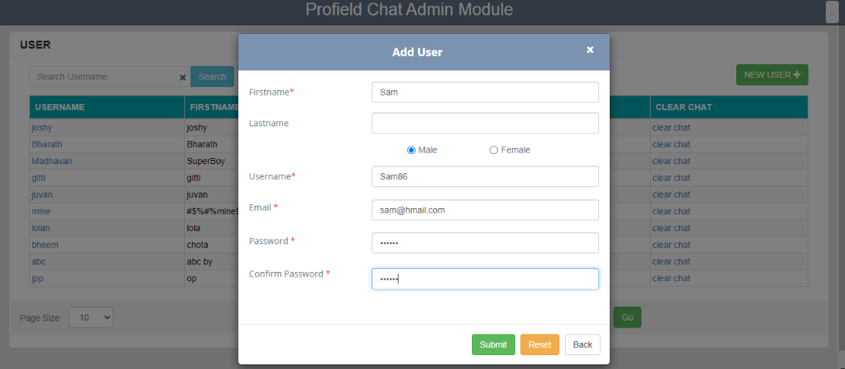
By clicking NEW USER Button, admin can add new users into the application.

EDIT CUSTOMER
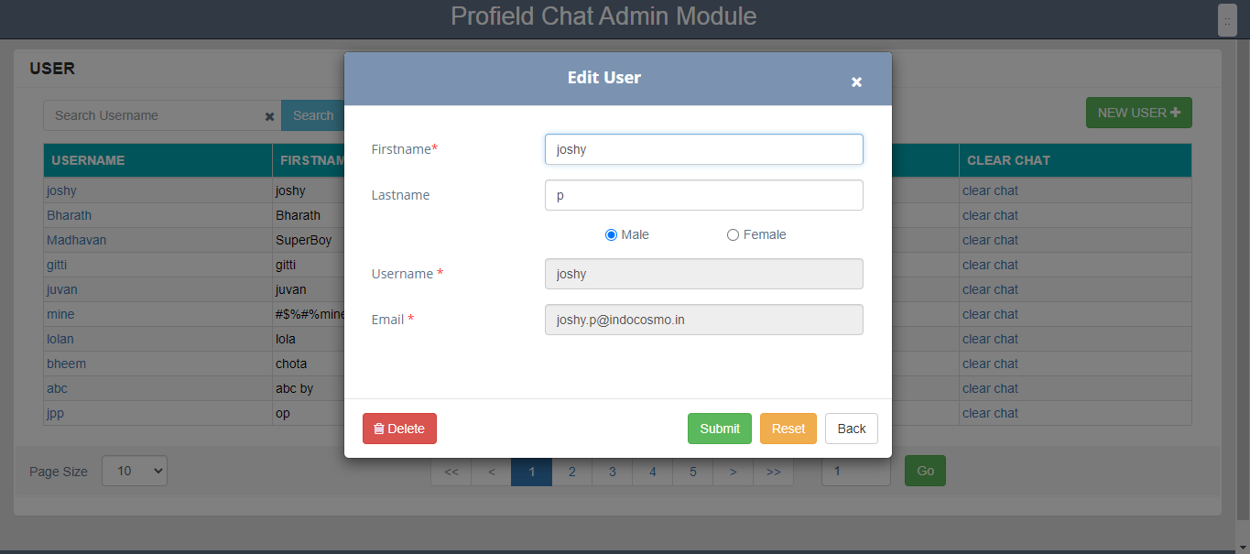
By clicking the username from the list, we can edit the details of that particular user. Also we can delete the same user from the application.

CLEAR CHAT

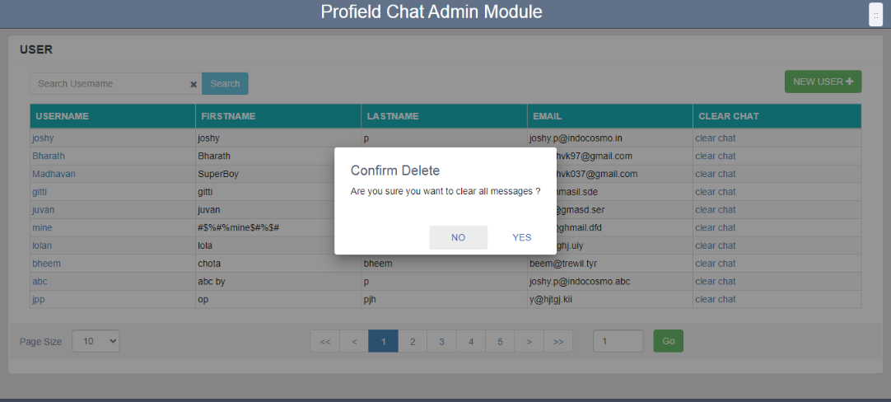
By clicking Clear Chat from the list, we can delete all messages of that particular user.

WEB APPLICATION (CLIENT)
A customer or a product owner can login to the application using the web application
Login URL :https://hikari.in/profield-chat/login

2.1 CUSTOMER SIGN UP
Anybody register using the ‘Sign up’ feature from the login screen becomes a Customer. Also customers defined through the admin module can also login to the application using the Username and password.
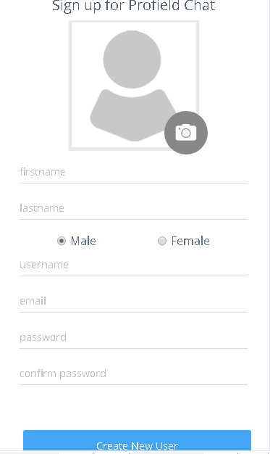
Customer can login to the application using the Username and password. On successful login, Home page for customer will be displayed.
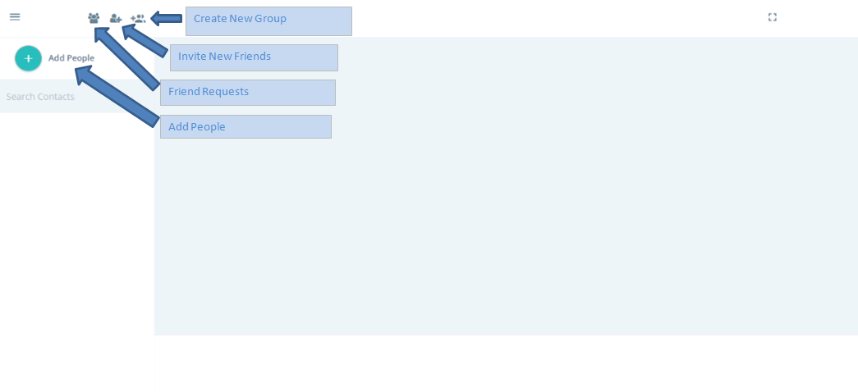
- Friend Request : We can see all friend requests that people send via email/by usernames.
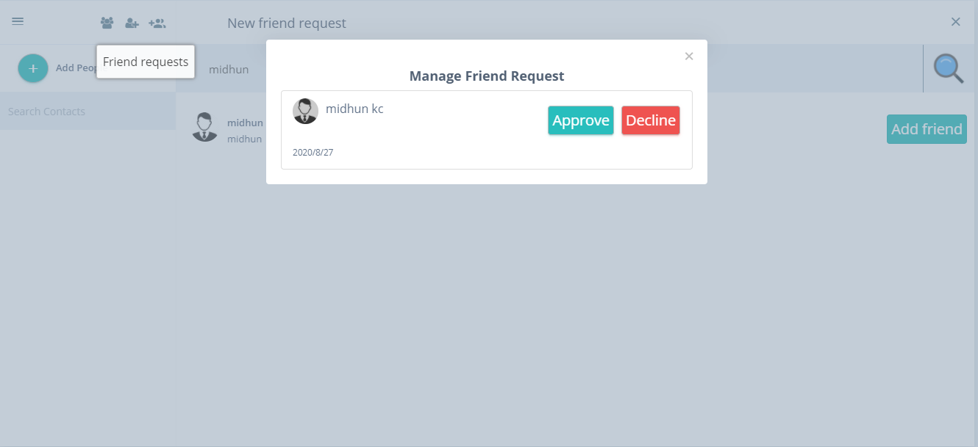
- Invite New Friends : We can invite other people with their email id.
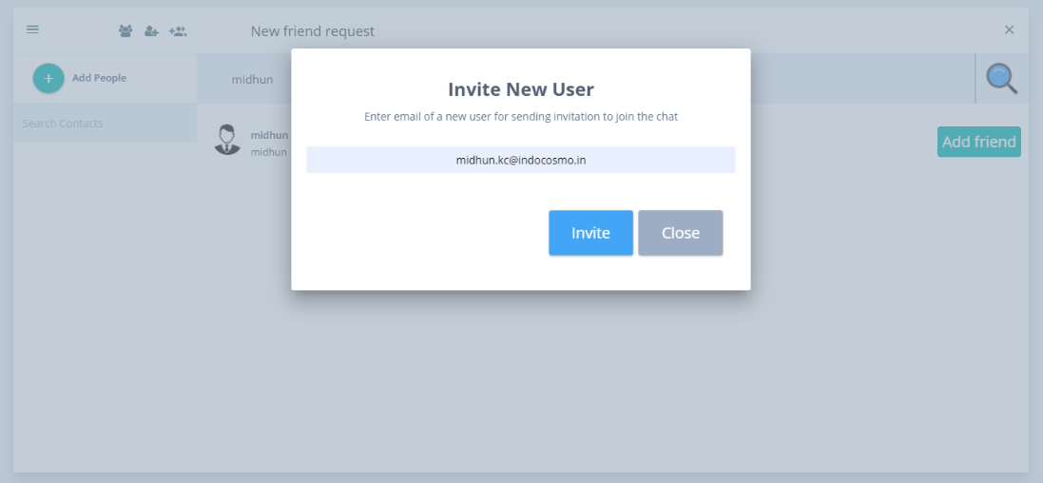
- Create New Group : We can create private groups with our contact list.
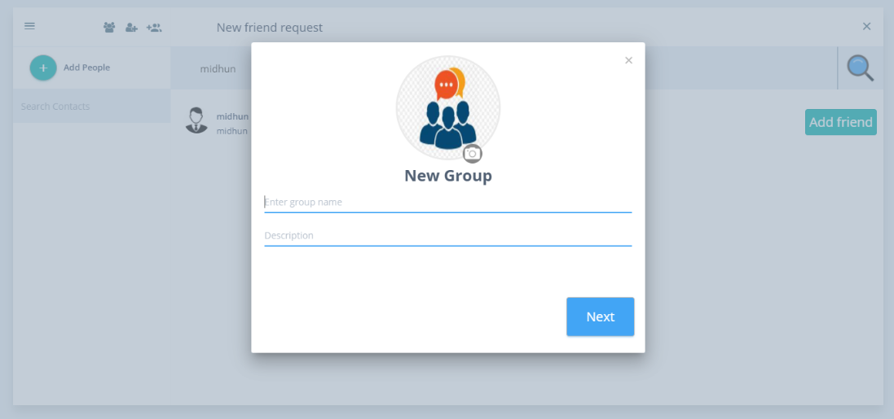
- Add People : We can search by username of the people in the chat.
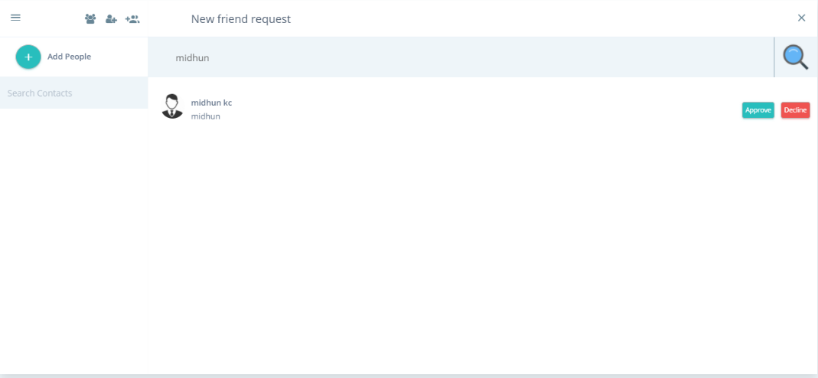

2.2 ONLINE/OFFLINE CONTACTS
The online friends should be indicated by green button

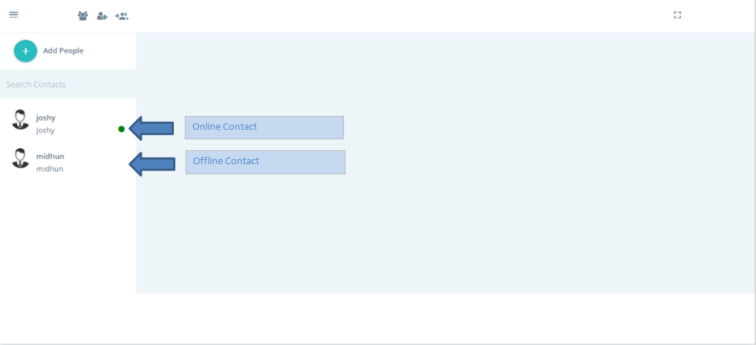

2.3 CHAT SCREEN
Clicking on any contact list opens the corresponding chat window.
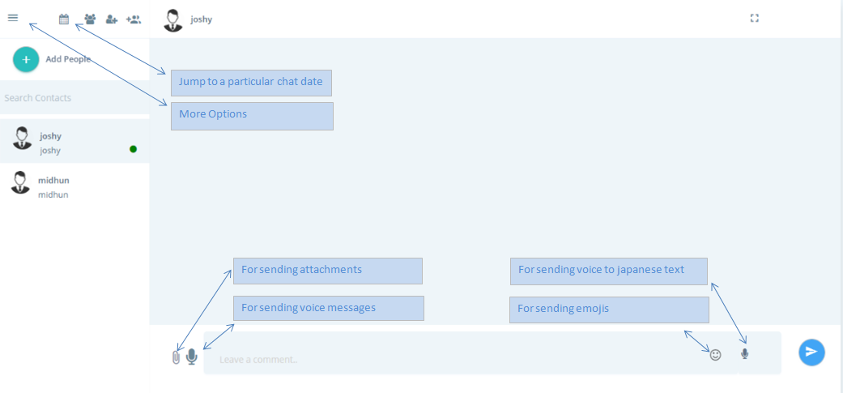

- More Options :
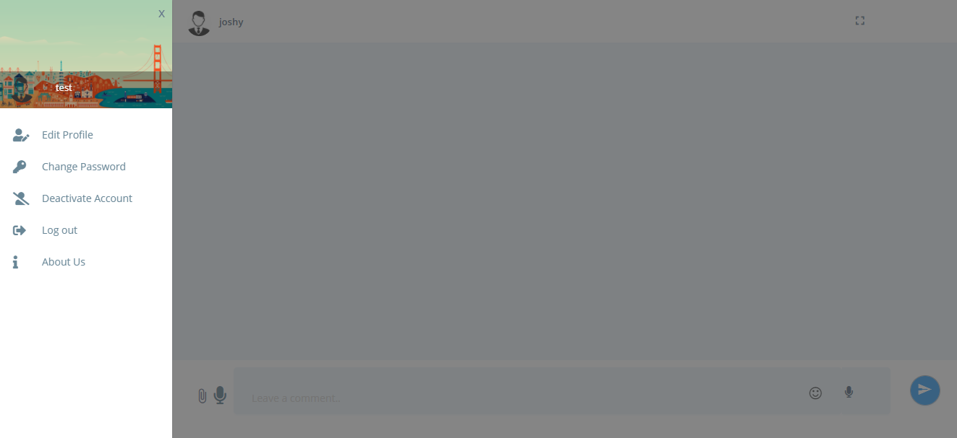
- Edit Profile : User Can change their profile photo, Firstname, last name and gender
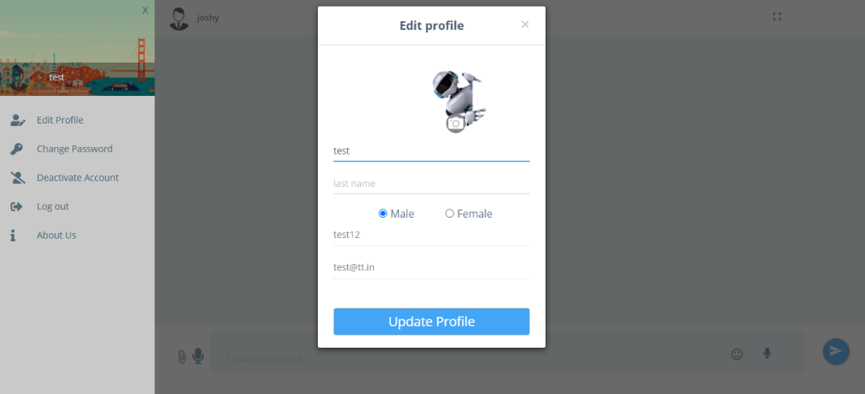

- Change Password : User can change their password
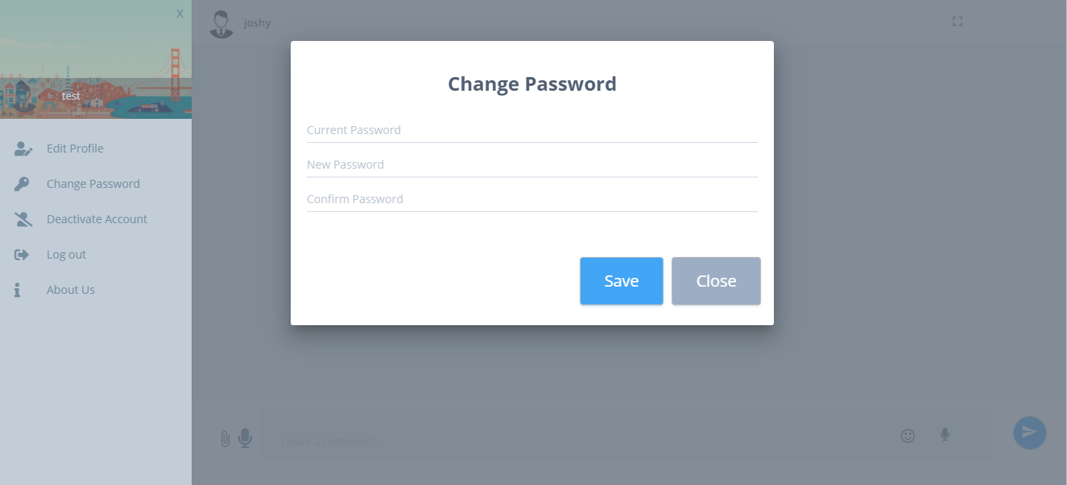
- Deactivate Account : User can deactivate their account.
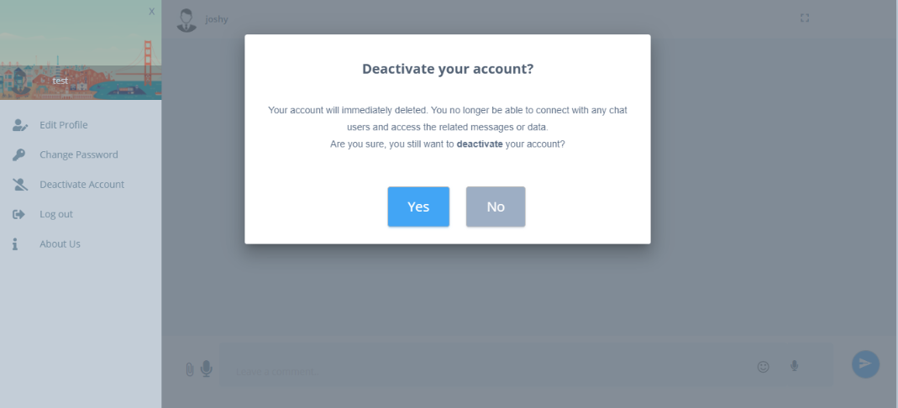
- Logout : Option for logout from the application.
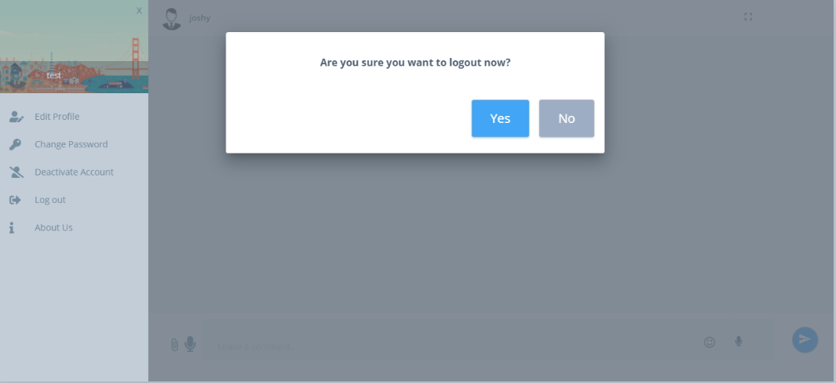
- About Us : It shows the details of the company and the current version of the application.
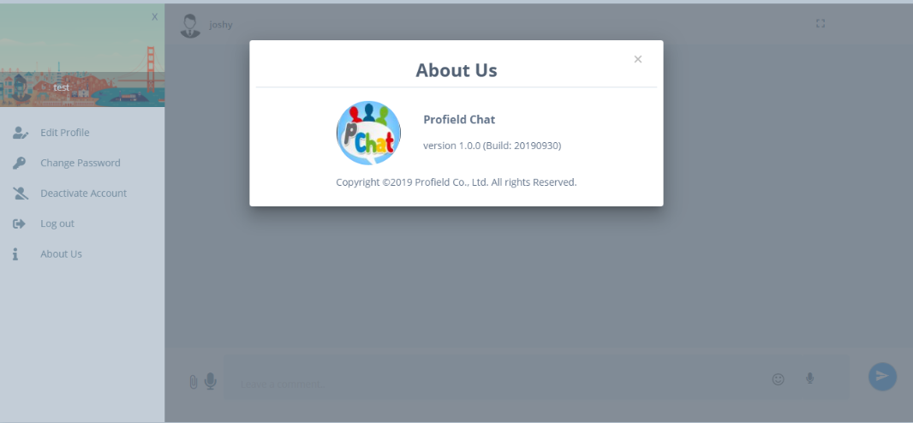
- Jump to a particular date of chat : This will allow us to pick up a specific date chat.
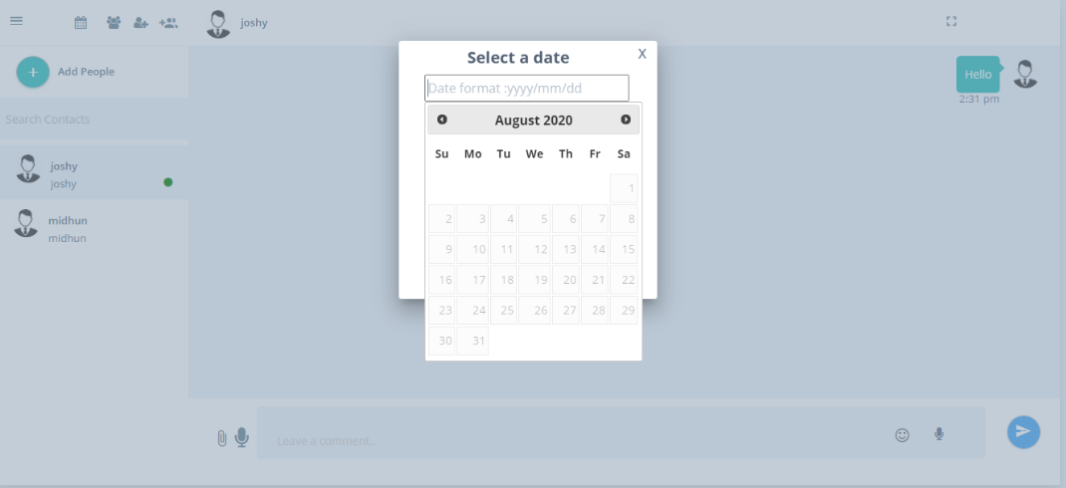

2.3 DELETE MESSAGES
Users can delete their own messages by double clicking on their messages.
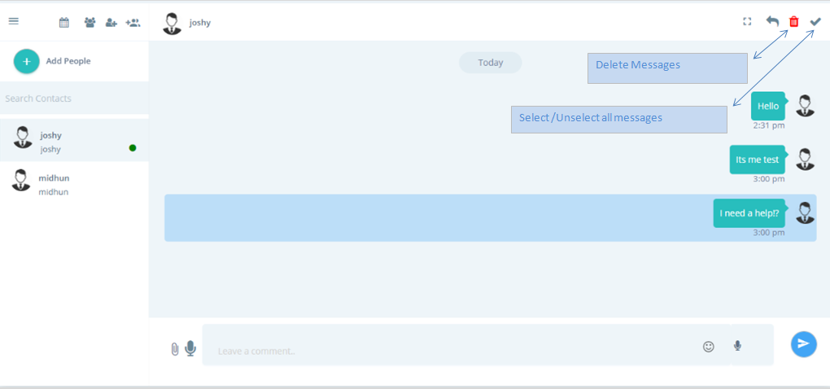

2.4 REPLY MESSAGE
Users can reply to their own messages or opponent messages.
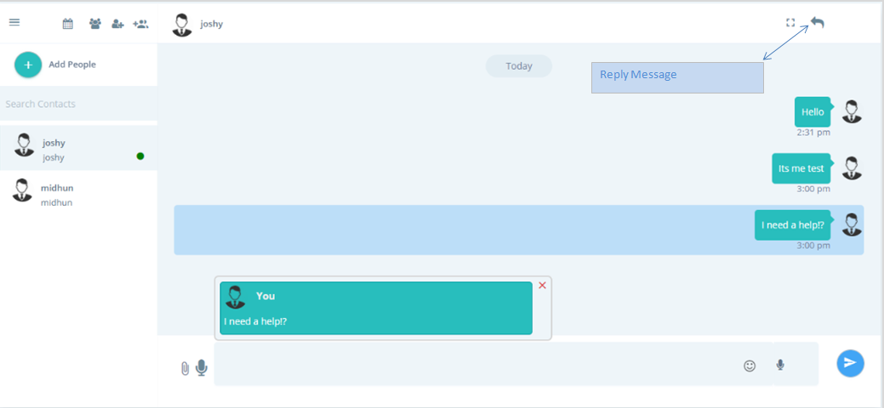

2.5 REACTIVATE ACCOUNT
User can reactivate their account by sign up with the same email id, but On activation all messages/group information related to the inactive user account will be deleted permanently.
